Self-Enrollment in Math or Chemistry Placement Exam Courses
Login to HuskyCT (http://huskyct.uconn.edu ) with your NetID and Password.
You will land on the Institution Page and under Self-Enroll Courses and Organizations you
should see Chemistry Placement Exam course:
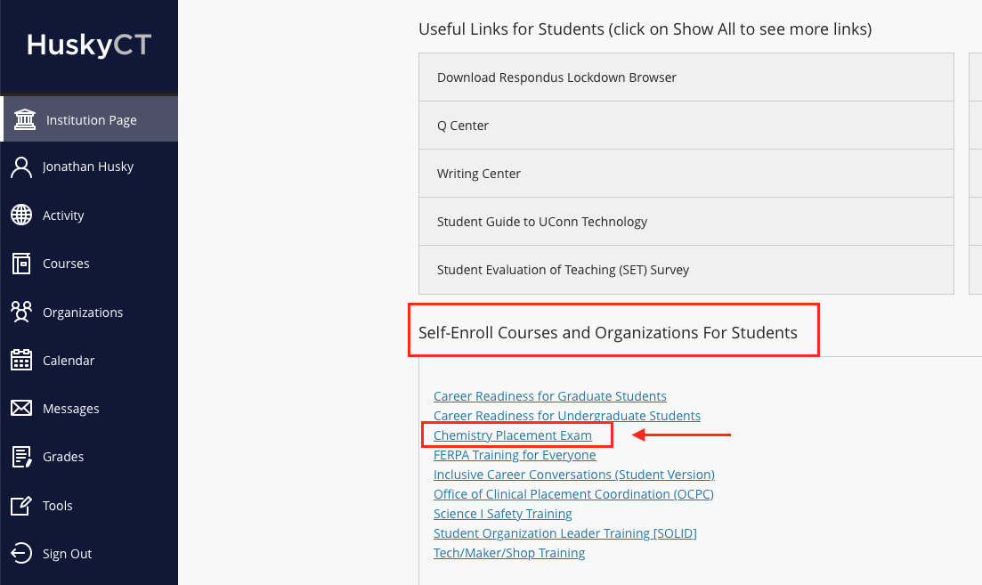

When you click on the link to Chemistry Placement Exam, you see a screen to self-enroll in the course:

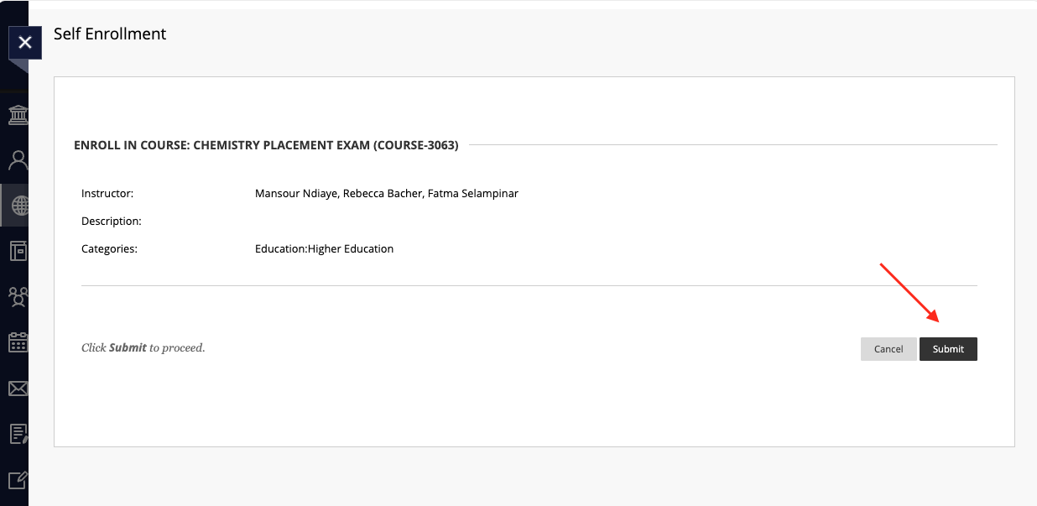

When you click on Submit, you get an enrollment confirmation page. If you click on OK at the bottom right corner, you will be directed to the course. You are now enrolled and any time you login to HuskyCT and click on Courses, you should see the Chemistry Placement Exam course there.

